**Binomial distribution**

In probability theory and statistics, the binomial distribution with parameters n and p is the discrete probability distribution of the number of successes in a sequence of n independent experiments, each asking a yes–no question, and each with its own boolean-valued outcome: success/yes/true/one (with probability p) or failure/no/false/zero (with probability q = 1 − p).

**It s used for the finite number (n)**

**Ex:**

See the below example for flipping the coins 5 times and finding the number of times getting heads.

So each time u flip the coin there will be 2 possibilities i.e heads or tails.

So for 5 flips u Wil have the below possibilities.

2.2.2.2.2= 32 possible outcomes for flipping the coins 5 times

Now let's find the probability of finding heads, i.e finding the p values

P

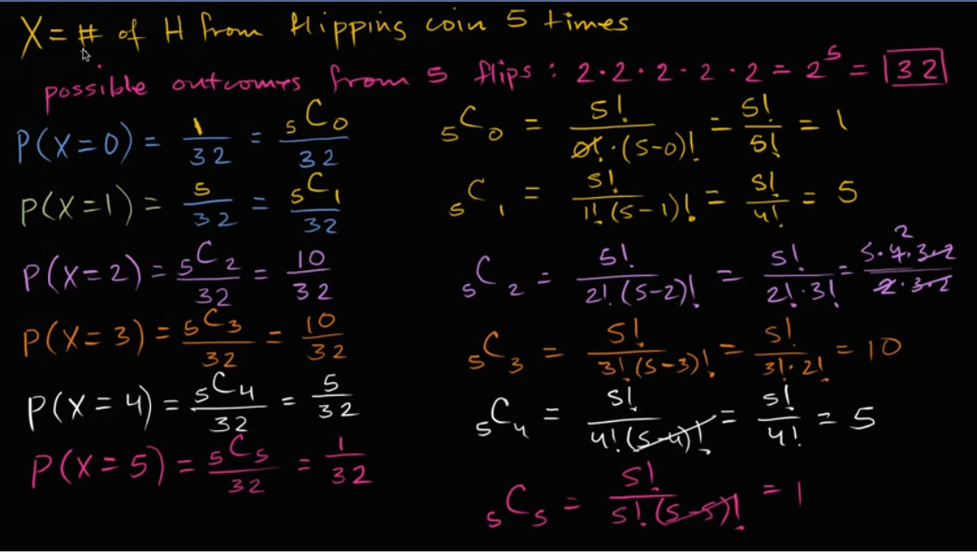

Similarly we can calculate the q values, ie. For the tails.

**q=1-p**

Les see the graph how the distribution is made along the given outcomes

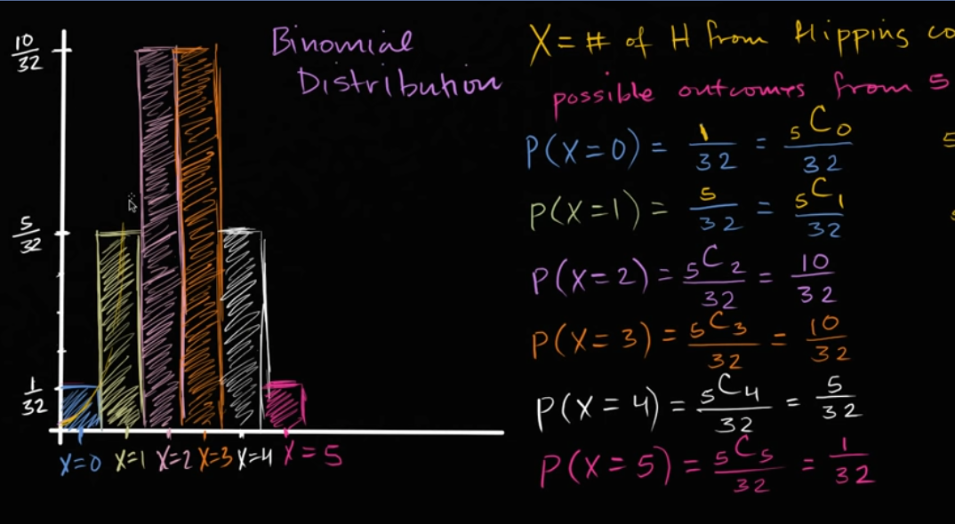

From the graph we can conclude that it is discreet probability distribution. And the graph s symmetrical.

And hence we can use binomial for the finite values of n

Ex: 10 books, 15 matches .. etc

**Binomial formula**:

The binomial distribution formula is:

b(x; n, P) = nCx * Px * (1 – P)n – x

Where:

b = binomial probability

x = total number of “successes” (pass or fail, heads or tails etc.)

P = probability of a success on an individual trial

n = number of trials

Note: The binomial distribution formula can also be written in a slightly different way, because nCx = n!/x!(n-x)! (this binomial distribution formula uses factorials (What is a factorial?). “q” in this formula is just the probability of failure (subtract your probability of success from 1).

binomialprobabilityformula

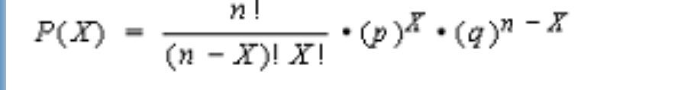

**Properties**:

The binomial distribution has the following properties:

The mean of the distribution (μx) is equal to n * P .

The variance (σ2x) is n * P * ( 1 - P ).

standard deviation (σx) is sqrt[ n * P * ( 1 - P ) ].

**Problem statement :**

